**Problem6 : Module 3**

**Sample table are as follows:**

**First 5 Dimension Tables:**

1. **Franchise table**

Simplest as same as ERD Table of Franchise.

|  |  |  |  |
| --- | --- | --- | --- |
| **Franchise** | | | |
| *FranchId* | *FranchRegion* | *FranchPostalCode* | *FranchModelType* |
| F1 | Northwest | 98011 | Full |
| F2 | Mountain | 80111 | Medium |
| F3 | Central | 45236 | Limited |

1. **Member**

First 3 rows are taken directly from the Member Table given in the ERD Diagram.

Next 1 Row (George) is the Guest Customer , he is given Type G.

Next 3 Rows (Corporate Customers) are given Type. C

MemEmail is NULL for some can be collected.

There is MemDate given for Guest or Corporate Customers.

|  |  |  |  |  |  |
| --- | --- | --- | --- | --- | --- |
| **Member** | | | | | |
| *MemId* | *MemName* | *MemDate* | *MemEmail* | *MemType* | *MemZip* |
| 1111 | Joe | 1-Feb-2009 | [joe@serv1.com](mailto:joe@serv1.com) | M1 | 98011 |
| 2222 | Mary | 1-Jan-2010 | [mary@serv2.com](mailto:mary@serv2.com) | M2 | 80112 |
| 3333 | Sue | 3-Mar-2011 | [sue@serv3.com](mailto:sue@serv3.com) | M3 | 45327 |
| 4444 | George |  | george@serv4.com | G | 45236 |
| 5555 | Frist Data |  |  | C | 80113 |
| 6666 | DU Tennis |  |  | C | 89256 |
| 7777 | Creek High School |  |  | C | 83698 |

**3.Product**

**ProdId is of three types:**

**PSC for Services**

**PS for Special Events**

**M for Membership**

|  |  |  |
| --- | --- | --- |
| ***Product*** | | |
| *ProdId* | *ProdName* | *ProdType* |
| *M1* | *Gold* | *Membership* |
| *M2* | *Platinum* | *Membership* |
| *M3* | *value* | *Membership* |
| PSC1 | Ball machine | Service |
| PSC2 | Private lesson | Service |
| PSC3 | Adult class | Service |
| PSC4 | Child class | Service |
| PS1 | Adult social | Special Event |
| PS2 | Pioneer social | Special Event |
| PS3 | Team practice | Special Event |

1. **Merchandise**

**MerchId starts from MC.**

|  |  |  |
| --- | --- | --- |
| ***Merchandise*** | | |
| *MerchId* | *MerchName* | *MerchType* |
| MC1 | Wilson balls | Balls |
| MC2 | Wilson racket | Racket |
| MC3 | Adidas shoes | Shoes |
| MC4 | Racket stringing | Racket |

1. **Calendar**

**As mentioned in the question:**

Your sample rows should include all revenue events in the range February 10, 2013 to February 21, 2013.

**CallId starts from letter C.**

|  |  |  |  |
| --- | --- | --- | --- |
| ***Calendar*** | | | |
| *CalId* | *CalDay* | *CalMonth* | *CalYear* |
| C1 | 10 | 2 | 2013 |
| C2 | 11 | 2 | 2013 |
| C3 | 12 | 2 | 2013 |
| C4 | 13 | 2 | 2013 |
| C5 | 14 | 2 | 2013 |
| C6 | 15 | 2 | 2013 |
| C7 | 16 | 2 | 2013 |
| C8 | 17 | 2 | 2013 |
| C9 | 18 | 2 | 2013 |
| C10 | 19 | 2 | 2013 |
| C11 | 20 | 2 | 2013 |
| C12 | 21 | 2 | 2013 |

**Fact Table**

1. **SalesRecord**

**Analyzing these records given in the source ERD:**

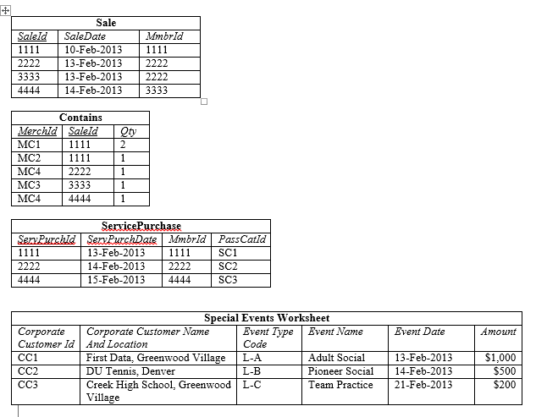

**Five Entries from Contains Table,**

**Next Three from ServicePurchaseTable,**

**NextThree from SpecialEvents Table**

**Last three are Membership.**

**There will be Null values here.**

Franchise Id’s are randomly written.

|  |  |  |  |  |  |  |  |  |  |  |
| --- | --- | --- | --- | --- | --- | --- | --- | --- | --- | --- |
| *RecordNo* | *isMerchandise* | *isService* | *MerchId* | *MemId* | *CallId* | *ProdId* | *FranchId* | *SalesQty* | *SalesUnitPrice($)* | *TotalAmt($)* |
| 1 | Yes | No | MC1 | 1111 | C1 | NULL | F1 | 2 | 3 | 6 |
| 2 | Yes | No | MC2 | 1111 | C1 | NULL | F1 | 1 | 200 | 200 |
| 3 | Yes | No | MC4 | 2222 | C3 | NULL | F2 | 1 | 40 | 40 |
| 4 | Yes | No | MC3 | 3333 | C3 | NULL | F3 | 1 | 100 | 100 |
| 5 | Yes | No | MC4 | 4444 | C4 | NULL | F1 | 1 | 40 | 40 |
| 6 | No | Yes | NULL | 1111 | C3 | PSC1 | F2 | 1 | 15 | 15 |
| 7 | No | Yes | NULL | 2222 | C4 | PSC2 | F3 | 1 | 75 | 75 |
| 8 | No | Yes | NULL | 4444 | C5 | PSC3 | F1 | 1 | 150 | 150 |
| 9 | No | Yes | NULL | 5555 | C3 | PS1 | F2 | 1 | 1000 | 1000 |
| 10 | No | Yes | NULL | 6666 | C4 | PS2 | F3 | 1 | 500 | 500 |
| 11 | No | Yes | NULL | 7777 | C12 | PS3 | F2 | 1 | 200 | 200 |
| 12 | No | Yes | NULL | 1111 | C2 | M2 | F3 | 1 | 800 | 800 |
| 13 | No | Yes | NULL | 2222 | C3 | M1 | F2 | 1 | 1000 | 1000 |
| 14 | No | Yes | NULL | 3333 | C4 | M3 | F1 | 1 | 300 | 300 |